**[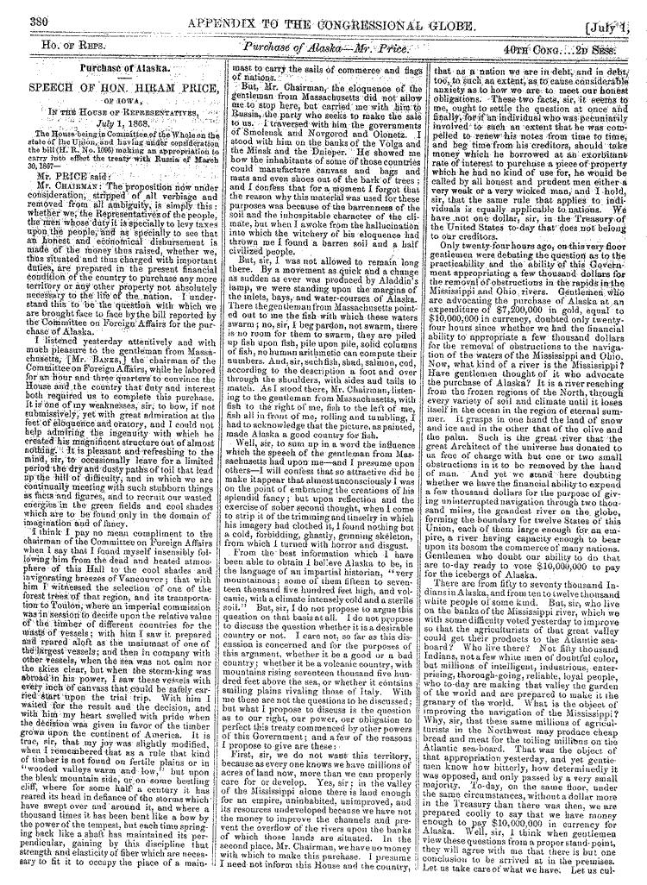](http://memory.loc.gov/ll/llcg/083/0800/08600380.tif)**[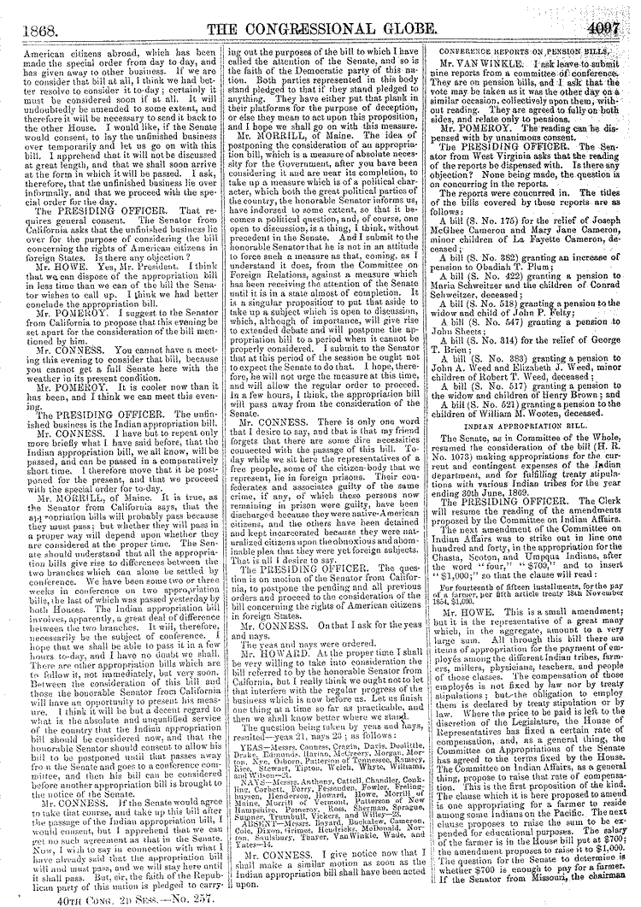](http://memory.loc.gov/ll/llcg/083/0000/00054097.tif)[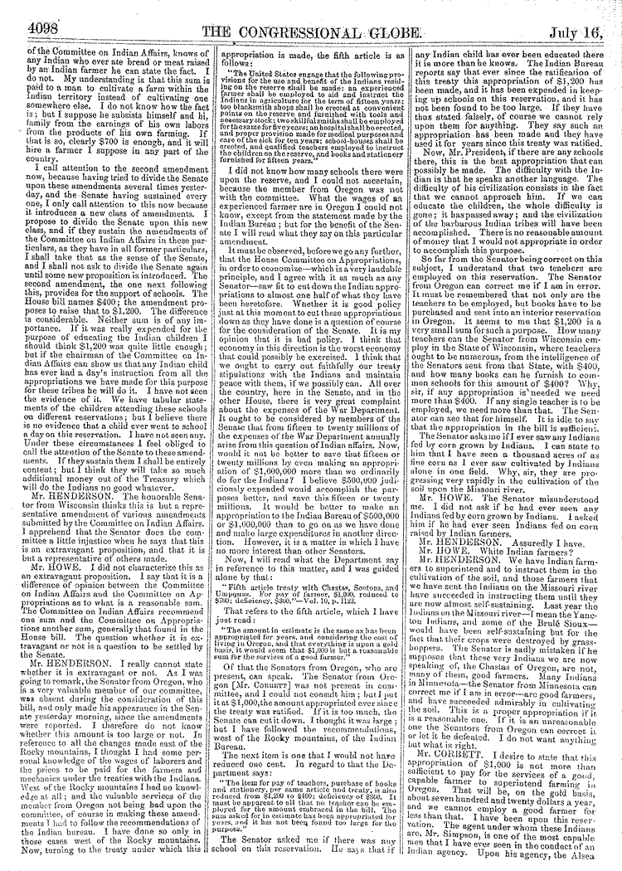](http://memory.loc.gov/ll/llcg/083/0000/00064098.tif)[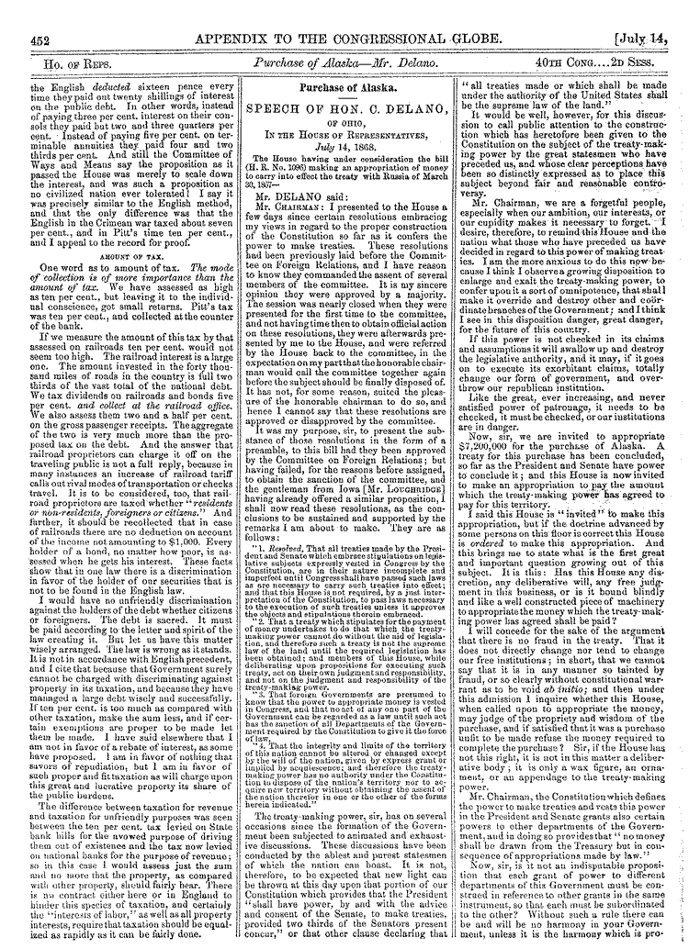](http://memory.loc.gov/ll/llcg/083/0900/09320452.tif)[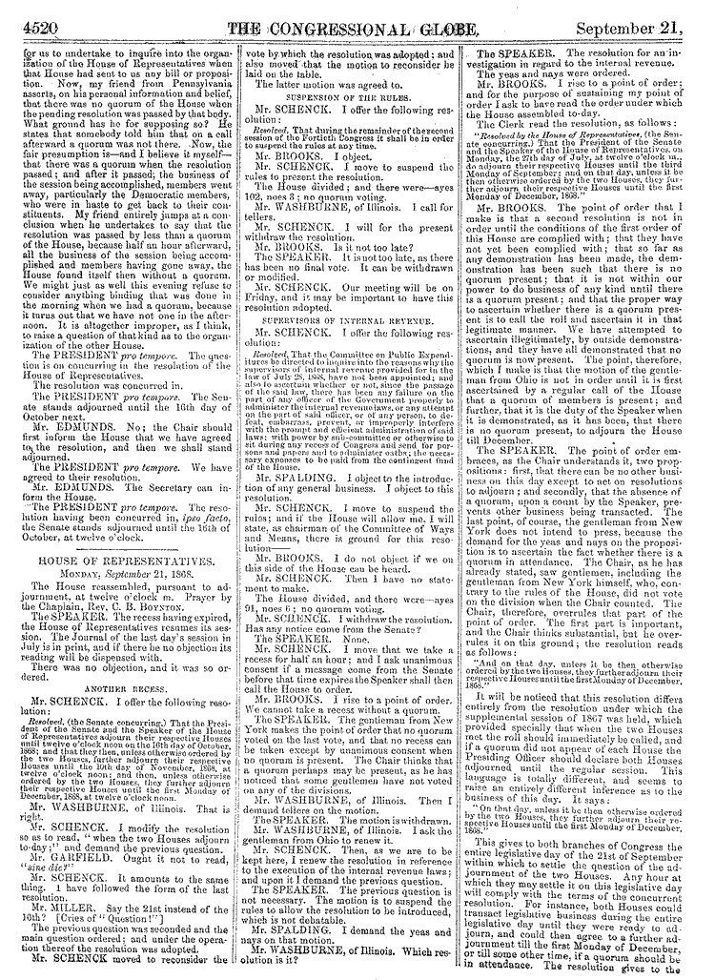](http://memory.loc.gov/ll/llcg/083/0400/04284520.tif)[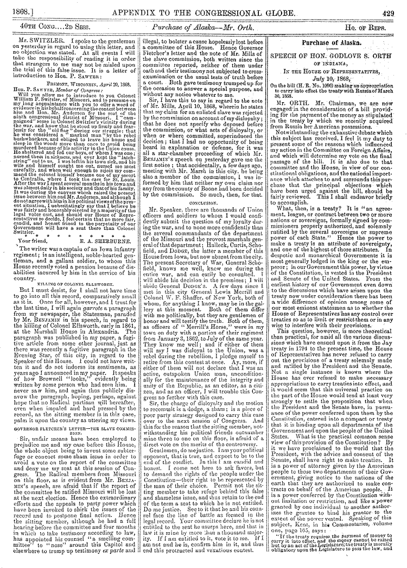](http://memory.loc.gov/ll/llcg/083/0900/09090429.tif)